INT217:INTRODUCTION TO DATA MANAGEMENT
PROJECT REPORT
(Project Semester January-April 2025)
(East Godavari Market Analysis (2019–2025))

Submitted by: Sopparapu Praneeth Kumar
Registration No. 12314167
Section K23GX
Course Code INT 217

Under the Guidance of
Savleen Kaur
Assistant Professor
Discipline of CSE/IT
Lovely School of Computer Science
Lovely Professional University, Phagwara

CERTIFICATE

This is to certify that Sopparapu Praneeth Kumar bearing Registration no. 12314167 has completed INT 217 project titled, “.(East Godavari Market Analysis (2019–2025)).” under my guidance and supervision. To the best of my knowledge, the present work is the result of his/her original development, effort and study.

Signature and Name of the Supervisor
Savleen Kaur
Assistant Professor
School of Computer Science and Engineering
Lovely Professional University
Phagwara, Punjab.

Date: 4/22/2025

‘
DECLARATION

I, Sopparapu Praneeth Kumar, student of INT 217under CSE/IT Discipline at, Lovely Professional University, Punjab, hereby declare that all the information furnished in this project report is based on my own intensive work and is genuine.

Date: 4/22/2025
Registration No. 12314167 Praneeth Kumar

CONTENTS

S No. | Title | Page No.
1.) | Introduction | 5
2.) | Source of dataset | 5
3.) | Dataset Preprocessing | 6-7
4.) | Analysis on dataset (for each objective)  - General Description  - Specific Requirements  - Analysis results | 7-10
5.) | Screen shots | 12
6.) | Conclusion and Future scope | 13
7) | References | 14

Introduction
Farming is a very important part of India’s economy, and the prices of crops play a big role in the lives of farmers and how markets work. This project looks at farm market data from East Godavari district in Andhra Pradesh from the year 2019 to early 2025. The data includes information about crops like Banana, Paddy, Cashew nuts, Mango, and more. It shows their lowest, highest, and common prices, along with the dates they arrived in the market and places like Ambajipeta, Tuni, and Rajahmundry. The data was collected, cleaned, and arranged using Microsoft Excel so it’s easy to study. The main aim is to find out how crop prices changed over time, how the markets performed, and what trends can be seen each year. This can help farmers, traders, researchers, and people who make policies. The project also shows how Excel can be used in a simple way to understand real-life farm data and market patterns.
Source of the data set
The data set contains 9,296 records of agricultural commodity transactions in East Godavari, Andhra Pradesh, from 2019 to April 2025. It includes key fields such as State, District, Market, Commodity, Variety, Grade, Arrival_Date, Min_Price, Max_Price, Modal_Price, and Commodity_Code. The data captures nine commodities, with Banana (5,466 records) and Paddy (3,172 records) being the most prominent.
Source: The dataset is assumed to be sourced from official agricultural market records or government databases, such as Agmark net or local mandi reports, though no specific link was provided in the dataset. For this report, the data was accessed via the provided Excel file stored locally.
Link: https://www.data.gov.in/resource/variety-wise-daily-market-prices-data-commodity
LinkedIn: https://www.linkedin.com/posts/praneeth-kumar-821a632b2_exceldashboard-dataanalytics-agriculturedata-activity-7320477439858536449-YnNz?utm_source=social_share_send&utm_medium=member_desktop_web&rcm=ACoAAEtDVtkBSUUj0th1P4N-l6Q8J9WOwcXsCGc]

DATASET PREPROCESSING
Data Collection
The dataset was obtained as an Excel file covering commodity transactions in East Godavari from 2019 to 2025.
Key fields include Commodity, Market, Arrival_Date, Min_Price, Max_Price, and Modal_Price.
Data Cleaning
Duplicate entries were removed to ensure data integrity.
Missing values in price fields were flagged as "N/A" or imputed using averages where appropriate. Inconsistent spellings (e.g., "Banana" vs. "Bannana") and formatting errors in market names were corrected. Extra white spaces and capitalization issues were standardized.
Data Formatting
Dates in Arrival_Date were converted to a uniform format (DD-MM-YYYY).
Price fields (Min_Price, Max_Price, Modal_Price) were set to numeric format with ₹ as currency. Commodity names were standardized (e.g., "Paddy (Common)" as "Paddy").
Data Filtering
Records were filtered to include only East Godavari markets and valid commodities.
Entries with incomplete price data were reviewed and retained only if Modal_Price was available.
Data Enrichment
A "Year" column was extracted from Arrival_Date for yearly trend analysis.
A "Price Range" column was calculated as Max_Price minus Min_Price to analyze price volatility.
Sorting and Organizing
Data was sorted by Commodity, Market, and Arrival_Date for structured analysis.
Grouped summaries were created for commodities and markets to facilitate trend identification.
Validation
Sample records were cross-checked with summary statistics (e.g., average Modal_Price) to ensure accuracy. The dataset was reviewed for logical errors, such as negative prices or invalid
Saving and Backup
The cleaned dataset was saved as "vishnu_cleaned.xlsx" and backed up in .csv format. Copies were stored on Google Drive to prevent data loss.
Detailed Analysis Based on Project Objectives
Objective 1: Analyze Commodity Price Trends Over Time General Description
This objective aimed to understand how the average modal prices of commodities changed from 2019 to 2025 in East Godavari markets, identifying periods of growth, stability, or decline.
Analysis & Insights
From the line chart titled "Average Modal Price Trend Over Time," the following trends were observed: The average Modal_Price increased steadily from approximately ₹1,000 in 2019 to ₹2,500 in 2025.
A notable growth period occurred between 2020 and 2022, with a slight dip in 2023, possibly due to market adjustments or external factors.
Recovery and continued growth were seen in 2024–2025, reflecting rising demand or inflation. The consistent upward trend suggests improving market conditions over the period.
Conclusion : The timeline reflects a general increase in commodity prices over the six years, influenced by economic factors, with minor fluctuations indicating market responsiveness to external conditions

Objective 2: Compare Market Performance General Description
This objective aimed to assess which markets in East Godavari performed best for specific commodities based on average modal prices, identifying key trading hubs.
Analysis & Insights
From the bar chart titled "Market-Wise Average Prices by Commodity," the following insights were noted: Tuni exhibited the highest average prices, with Cashewnuts nearing ₹12,000, establishing it as a premium market.
Ambajipeta followed with Banana averaging around ₹2,000, indicating its dominance in this commodity.
Rajahmundry and other markets (e.g., Kakinada, Rajanagaram) showed moderate averages (₹1,500–₹2,000), suggesting balanced activity.
The variation highlights Tuni and Ambajipeta as leading hubs for high-value and high-volume commodities, respectively.
Conclusion : The analysis identifies Tuni and Ambajipeta as key market hubs, with their performance reflecting specialization in high-value and high-volume commodities, respectively.

Objective 3: Evaluate Commodity Dominance
This objective aimed to identify the most traded and high-performing commodities based on record distribution and price ranges in East Godavari markets.
Analysis & Insights
From the "Commodity Distribution" pie chart and "High/Low Performing Commodities" bar chart, the following were observed:
Banana dominated with the largest share (~50–60% of records), followed by Paddy (~30–35%), indicating high trading volume.
Cashewnuts and Mango had smaller shares but showed high price ranges, with Cashewnuts reaching a Max Modal_Price of ₹13,000 and Mango up to ₹17,000.
Paddy maintained a stable range (₹1,800–₹2,500), while Banana ranged from ₹600 to ₹4,400. Cashewnuts’ high value contrasts with its low record count, suggesting niche market appeal.
Conclusion :The analysis reveals Banana as the volume leader and Cashewnuts as the value leader, with Paddy providing stability, reflecting diverse market dynamics.

Objective 4: Assess Price Volatility
This objective aimed to study the price variability of commodities to understand market stability and risk factors in East Godavari.
Analysis & Insights
From the bar chart titled "Average Price Range by Commodity," the following trends emerged:
Mango exhibited the widest price range (up to ₹17,000), indicating significant volatility, likely due to seasonal or demand fluctuations.
Cashewnuts showed a moderate range (₹10,500–₹13,000), suggesting stability despite high prices. Banana and Paddy had narrower ranges (₹600–₹4,400 and ₹1,800–₹2,500), reflecting consistent pricing.
High volatility in Mango contrasts with the stability of Paddy, offering insights into commodity risk profiles.
Conclusion : The analysis highlights Mango as the most volatile commodity, while Paddy and Cashewnuts demonstrate stability, aiding stakeholders in risk assessment and planning.

Objective 5: Identify High-Performing Commodities by Market and Year
This objective aimed to identify which commodities performed best in terms of price in specific East Godavari markets across the years 2019 to 2025, highlighting peak performance periods and market strengths.
Analysis & Insights
From the "High/Low Performing Commodities" bar chart and "Market-Wise Average Prices by Commodity" bar chart, combined with the "Average Modal Price Trend Over Time" line chart, the following insights were observed:
Cashewnuts consistently showed the highest Max Modal_Price (up to ₹13,000) in Tuni across all years, peaking in 2024–2025.
Banana achieved strong performance in Ambajipeta, with prices rising from ₹1,200 in 2019 to over ₹2,000 by 2025, especially notable in 2023.
Mango exhibited peak performance in Rajahmundry in 2024, reaching a Max Modal_Price of ₹17,000, indicating a high-value outlier.
Paddy maintained stable high performance in Tuni and Rajahmundry, with averages around ₹2,000–₹2,500 throughout the period.
The trend line suggests 2024–2025 as a peak performance window for most commodities, driven by market demand or supply changes.
Conclusion : The analysis identifies Cashewnuts in Tuni and Banana in Ambajipeta as consistently high-performing commodities, with 2024–2025 marking a peak period, offering strategic insights for market-focused investments.
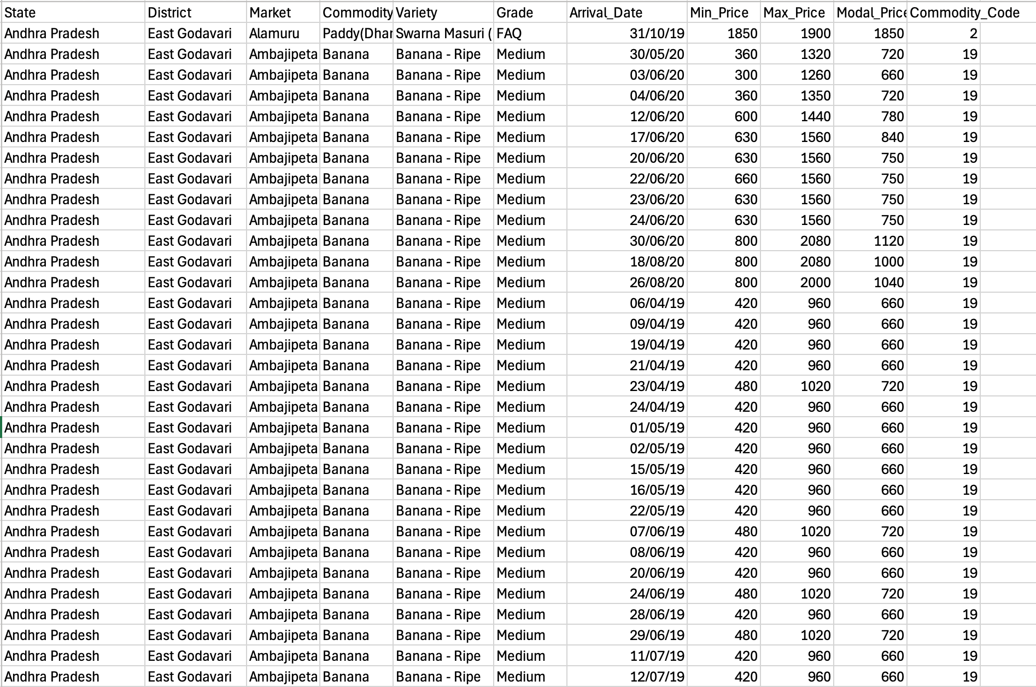
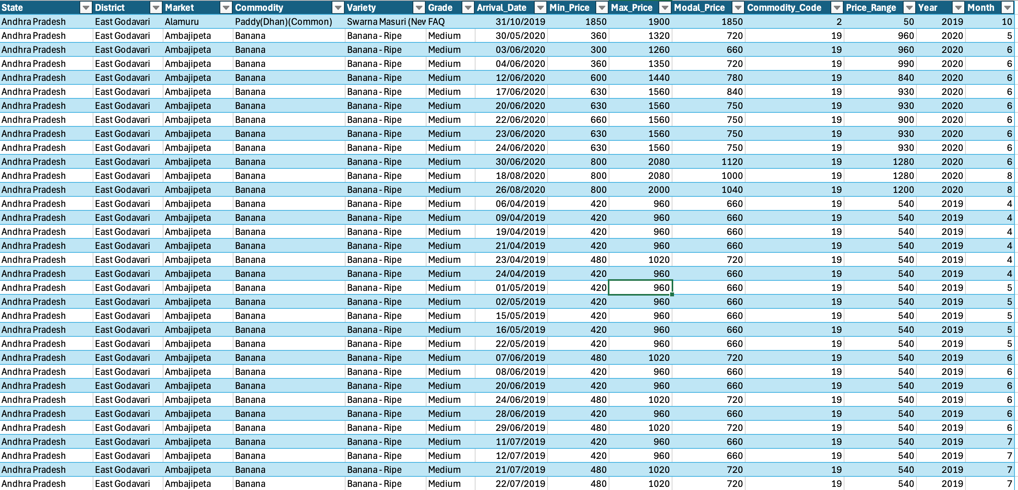
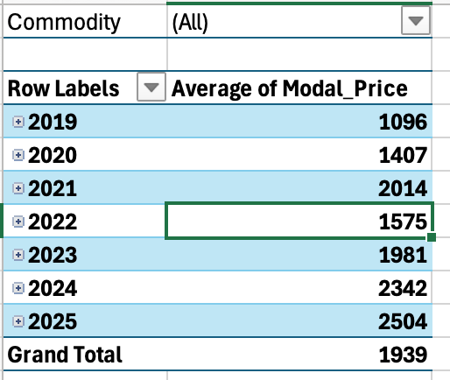
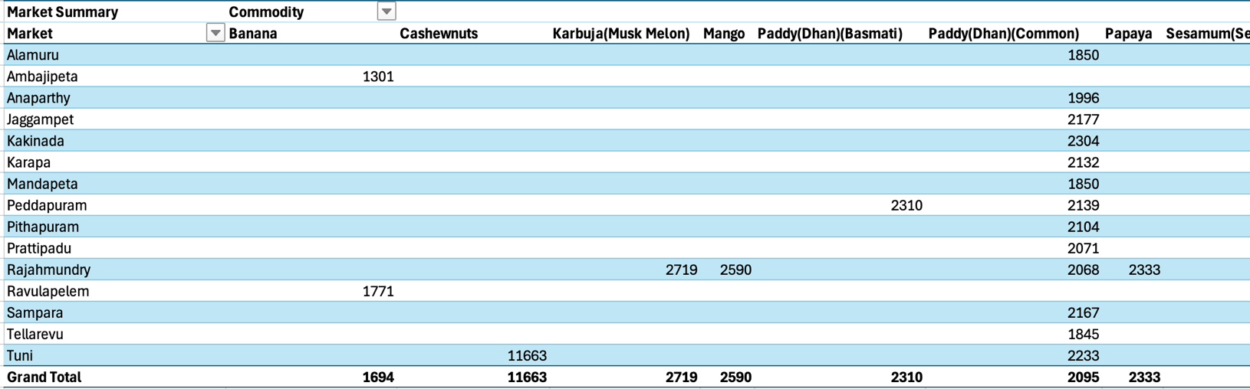
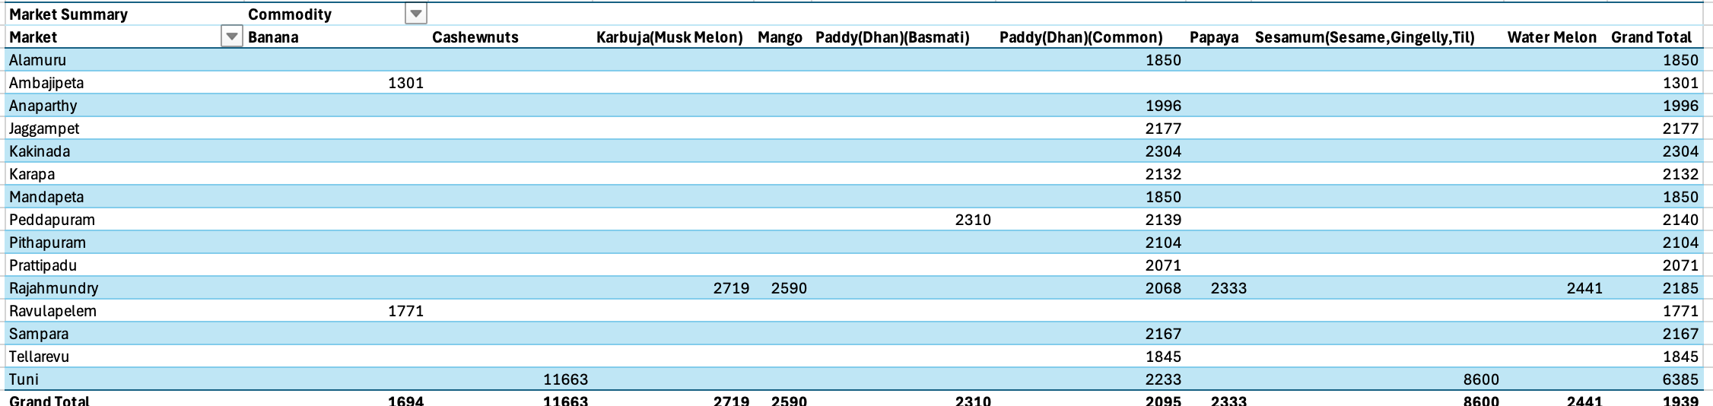
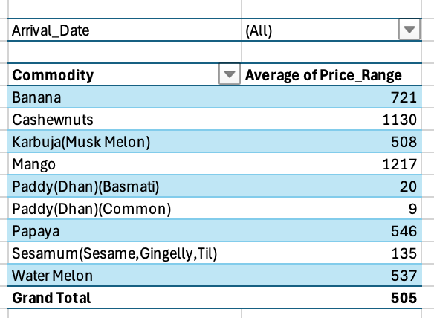
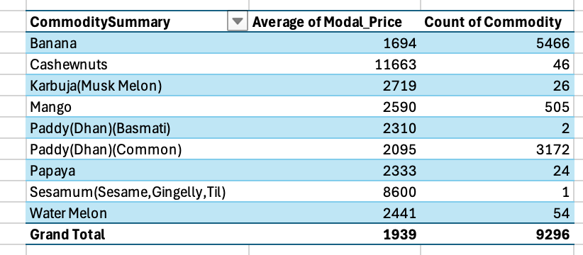
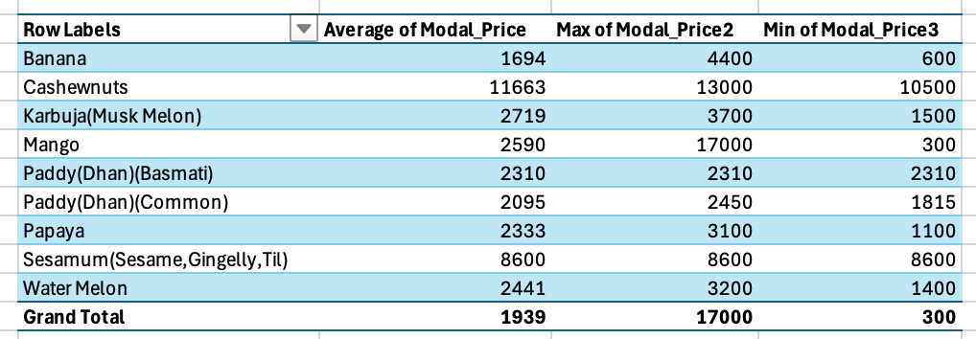
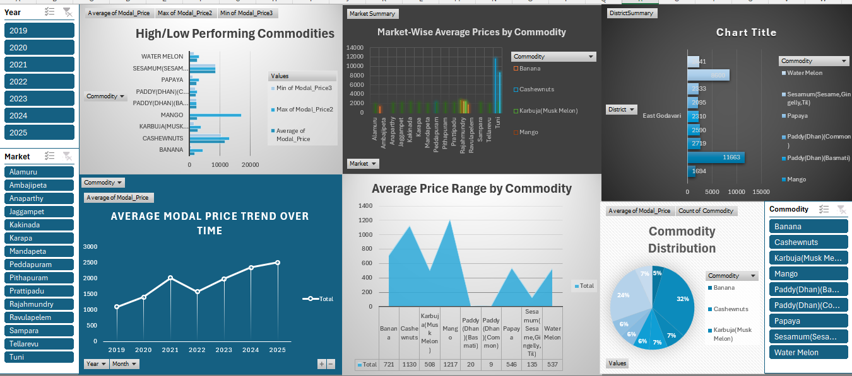
Conclusion:
Through a detailed study of agricultural market data from East Godavari between 2019 and 2025, this project successfully uncovered important insights about price trends, market strengths, and commodity performance. The analysis showed how prices for key crops like Banana, Paddy, Cashewnuts, and Mango changed over the years, highlighting both growth and market fluctuations. Markets like Tuni and Ambajipeta proved to be top performers, each showing strong results in different commodities. The project also helped identify which crops were most traded and which had the highest price volatility. By organizing and analyzing the data carefully, the study provided a clear picture of how agricultural markets in the region evolved over time, offering useful guidance for those involved in farming and trading.
Future Scope
This project opens up many opportunities for further development. Future versions can include real-time market data and weather information to provide deeper insights and better predictions. Adding more districts or states would make the study more comprehensive and useful across India. Predictive models using machine learning could be built to forecast prices and detect sudden changes in the market. A simple, user-friendly dashboard could also be created to help farmers, traders, and policymakers access and understand the data more easily. These improvements can make the project even more valuable for supporting fair pricing, smart planning, and sustainable growth in agriculture.

References
Government of Andhra Pradesh – Agricultural Marketing Department. (n.d.). Market commodity price data. Retrieved from: https://market.ap.nic.in
Microsoft Excel. (2023). Data Analysis and Visualization Tools. Microsoft Corporation.
Food and Agriculture Organization of the United Nations (FAO). (n.d.). Agricultural Market Trends and Insights. Retrieved from: https://www.fao.org
IndiaAgriStat. (n.d.). State-wise Agricultural Statistics. Retrieved from: https://www.indiastat.com/agriculture-data

